1. The maintenance model calculation is fine however, I observed that he didn’t implement the saving of the results so that we should have a view history page button where the saved results can be viewed and this should be recorded with date of execution. Then there is something else he didn’t actualize. I am placing below here the result I obtained from an execution.
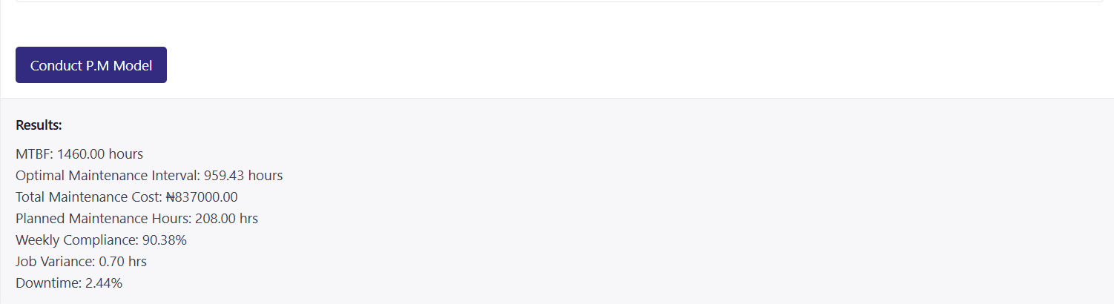
The two very important data from this result needed to plan for a preventive maintenance are the optimal maintenance interval and the planned maintenance hours. I am including below here how to use these two data for planning in a sketch which the system should be able to produce after the execution.
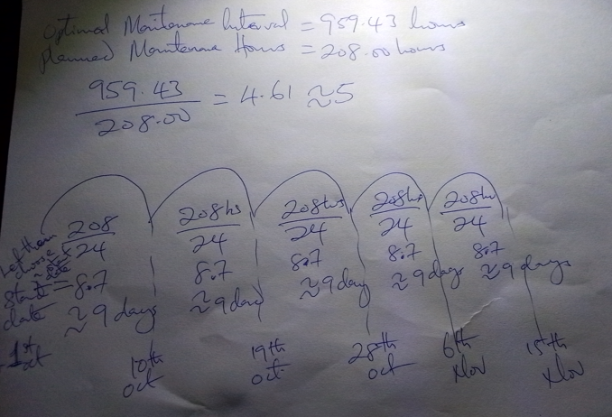
From these two results the period interval for each maintenance to be carried out on the equipment is obtained by dividing the optimal maintenance interval by the planned maintenance hours (The result must be in integer value) which gave 5 cycles (which is the five loops drawn). So for each loop we have a planned maintenance hours of 208 hours which when divided by 24hours of a day we have approximately 9 days. That is every 9 days maintenance must be carried out on the machine for 5 loops times. So, the maintenance group letter or head must fix a start day chosen which if it’s 1st of October (October has 31 days) which is the first maintenance by the 10th of October will be the 2nd maintenance day until on the 6th of Nov. when the five cycles will be completed. So, that mean the loop should stop on the 6th of Nov. and not 15th if they started the maintenance activity from the 1st of October.
So, please help me actualize this sketch on the model and there is every reason to save every data used in the computation and that of the results obtained especially the arrived dates of the planned maintenance.
2. For the organization structure view history page, this have been fully implemented however, I will want the results to be arranged according the date of execution. As it is now they are all scattered.
.
3. Back to the Redundancy Index (supervision cost), I can’t find any button to save result to the history page. Here is a snap shot from the screen. There are two issues here to be resolved. The first is the saved button which is nowhere to be found after the execute button is clicked on. Then secondly,
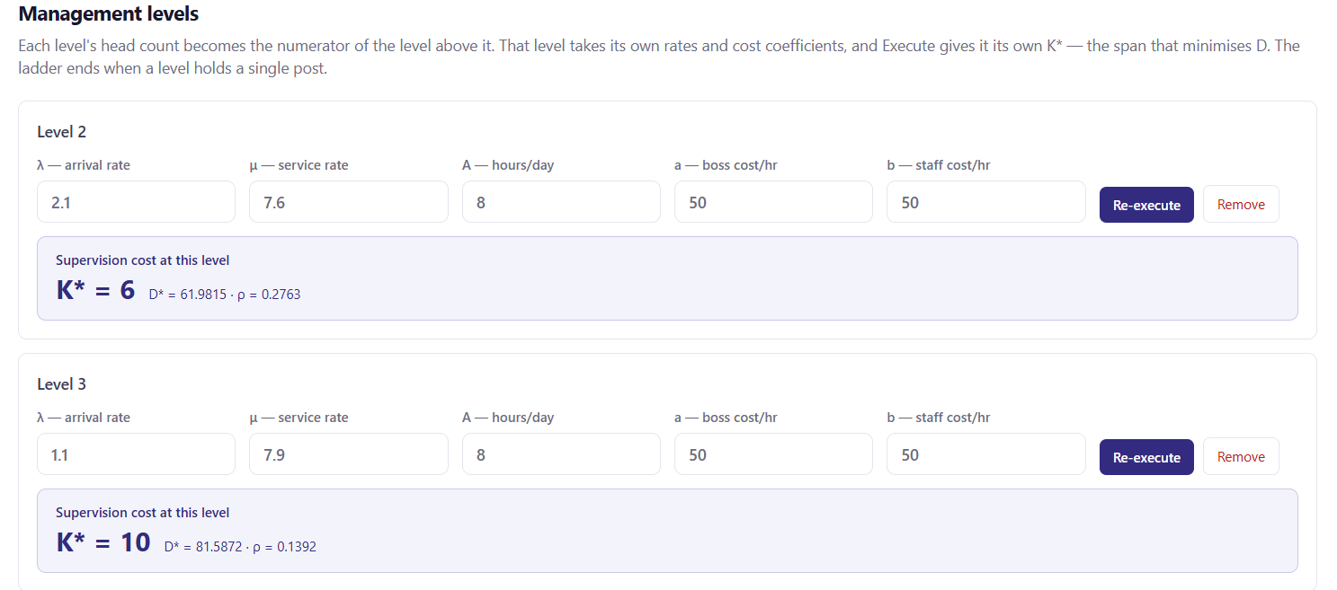
The number of staff found redundant is still not reflecting. Like for level 2, to find the number of staff redundant we have to divide the number of staff (if from the work sample method for supervisory staff or the number of management staff at which ever level that is picked) by the k* result obtained. And this number of staff determined should show along where the K* and other results are displayed.
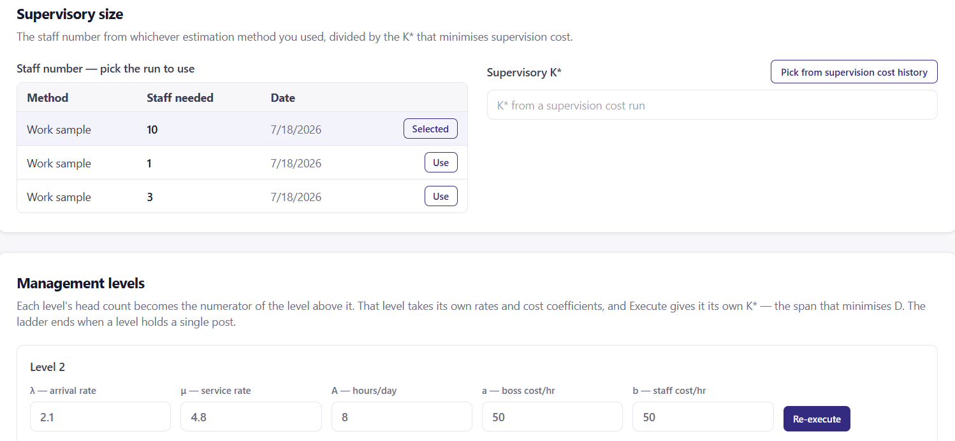
Then the in the view history page, the number of staff obtained shouldn’t be missing as in the snap shot below.
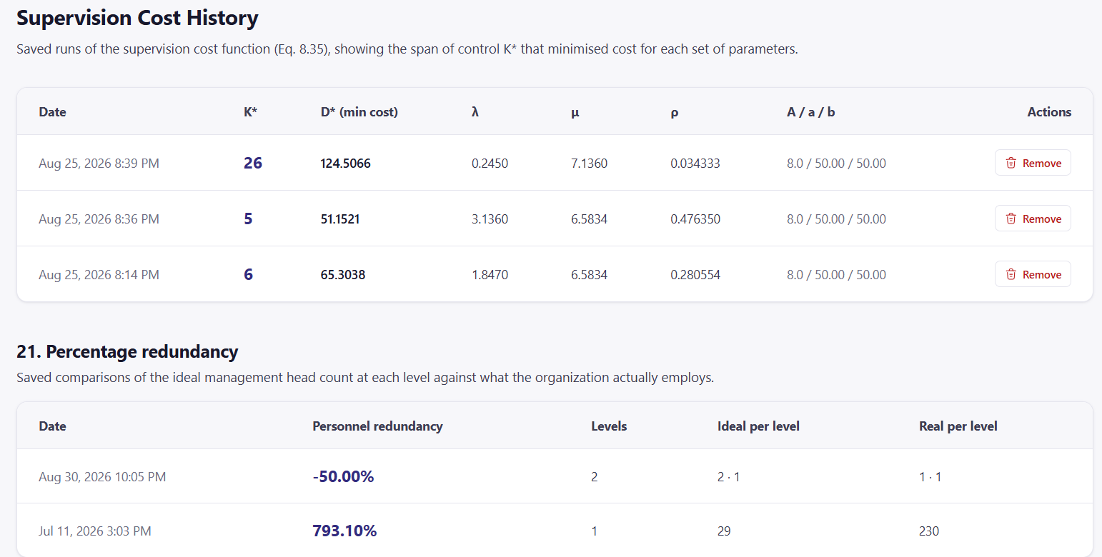
4. The appraisal motivation have also been fully implemented. I hope any staff earning these can print out their awards because this is very important. Thasnks

